**#.Find all the least occurred strings of str1 = "aaaabbbccdef"**

**#Program**

**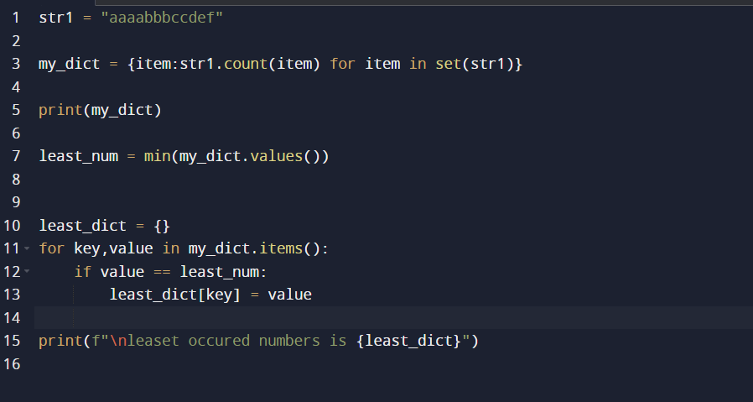  
  
#Output**

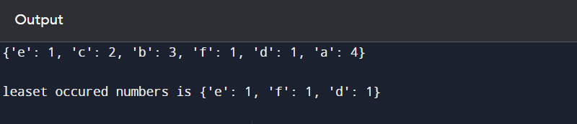

**# Find the second least occurred strings of str1 = "aaaabbbccdef"**

**#Program  
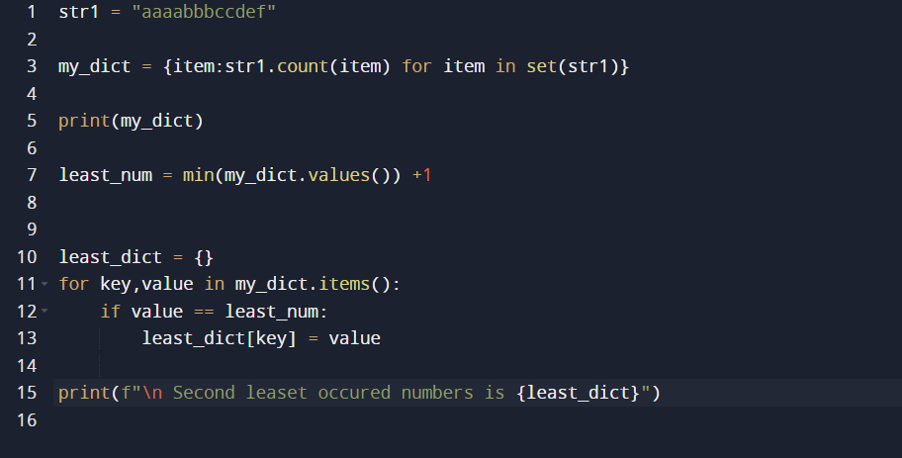**

**#Output  
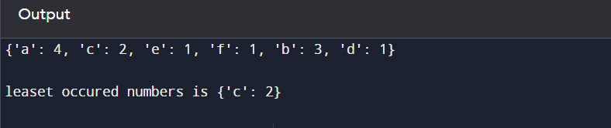**

**# Find All Substrings of a string “abc”**

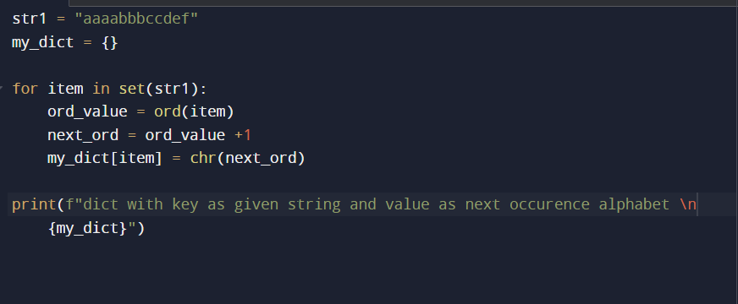

**#OUTPUT**

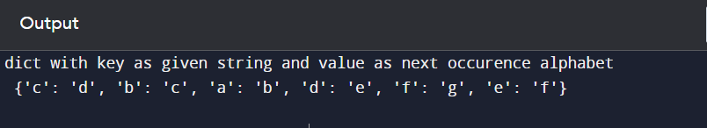

**# Count Occurrences of a Substring“hello” in "hello hello world"**

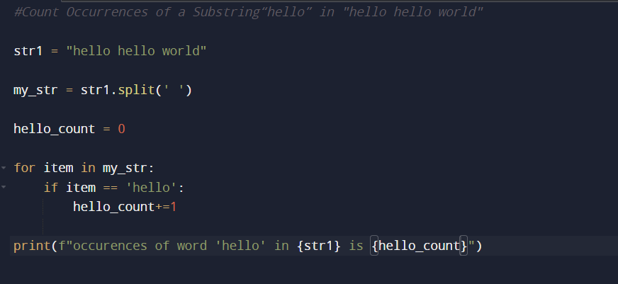

**#Output**

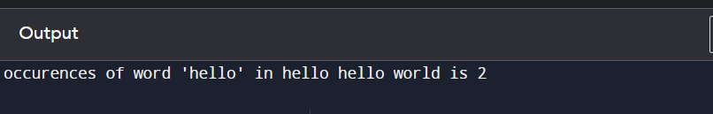

**# Remove Duplicates from a String “Bananaaaaa”**

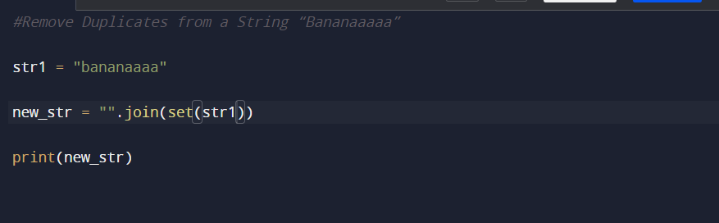

**#Output**

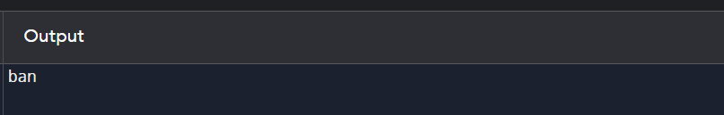

**#Check string is Anagram or not ?**

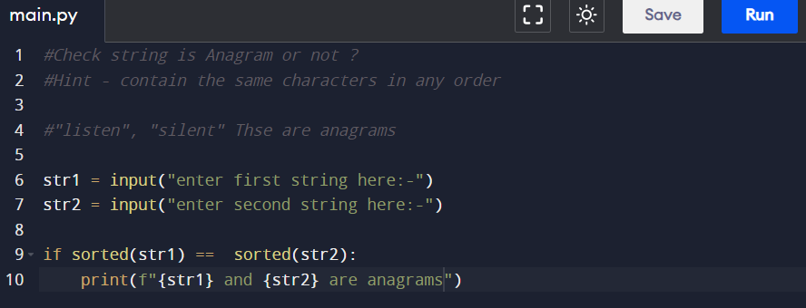

**#Output  
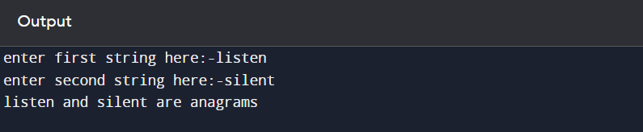  
  
  
# Duplicate Characters in a string programming**

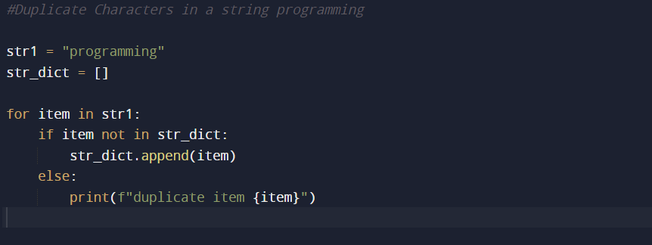

**#Output  
